# Spring Core – Load Country from Spring Configuration XML .

# Project Structure –

# 

# Main Class –

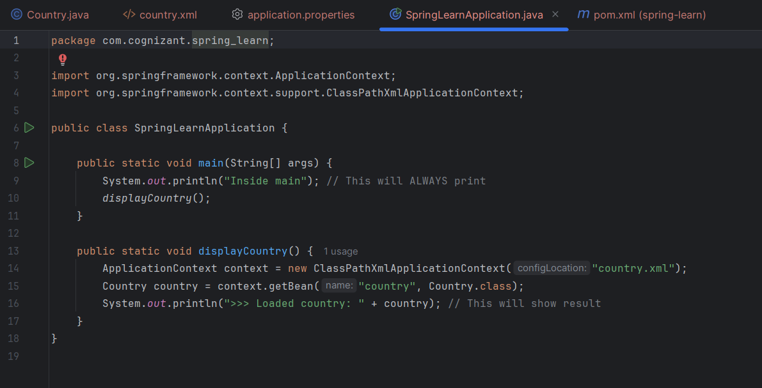

# Pom.xml –

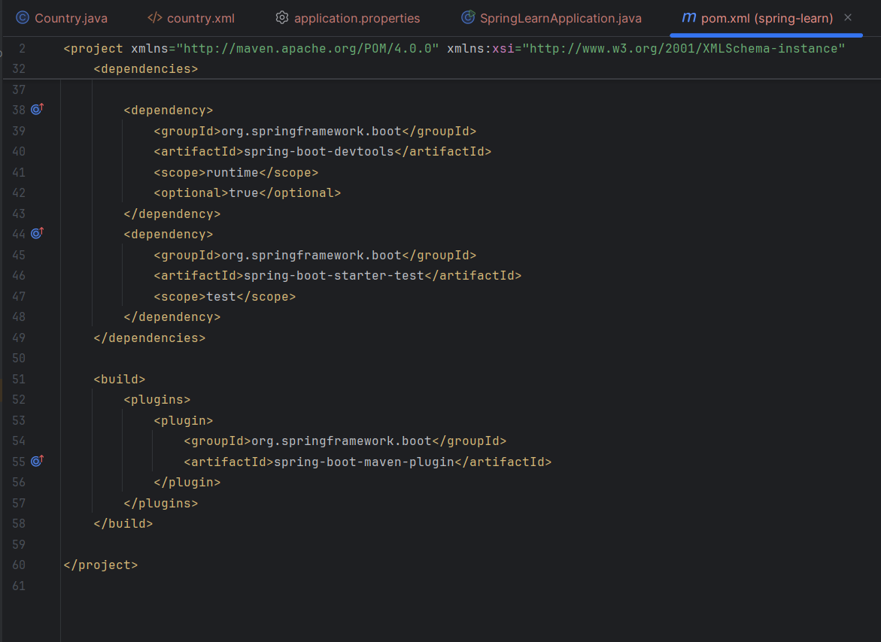

# Country.xml –

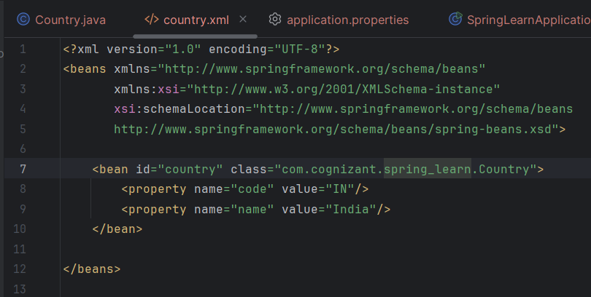

# Output –

